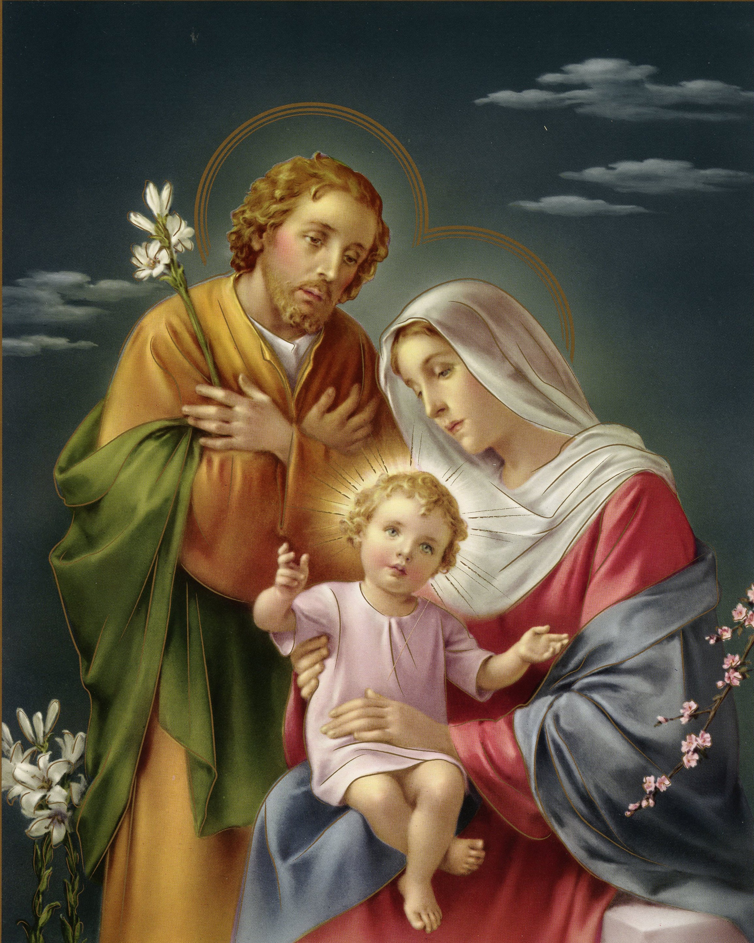 LAO CATHOLIC PASTORAL CENTER OF USA AND CANADA
LAOTIAN NATIONAL CATHOLIC CONFERENCE 2023
JULY 06, 2023 THROUGH JULY 08, 2023 AT ST. DAVID of WALES ROMAN CATHOLIC CHURCH
5641 ESMOND AVE, RICHMOND, CA 94805

REGISTRATION FORM
$40.00 per Person (One form per person, please!)

Last Name:____________________________ First Name: ______________________________
Gender: Male Female Classification: Adult Youth (age:____)
Address:_______________________________________________________________________
City:________________________ State:________________ Zip Code:_____________________
Phone# with area code:____________________________________________
Community/Parish:______________________________________
Arrival by: Personal Vehicle Chartered Bus Airplane
Note/Remark: __________________________________________________________________
Note: This fund is intended to help and support our costs for National Conference directly.

Please send the register form and check/Money order and make payable to: Lao Catholic Association of Fort Worth and mail to Aisavanh Pradaxay, 7340 Indiana Ave, Fort Worth, TX 76137. If you prefer, you may Zelle to LCPCenter2019@gmail.com. All forms must be post marked no later than May 31st, 2023.

The following Hotels are within 4-5 miles of ST. David of Wales Roman Catholic Church:
1. Holiday Inn Express Hotel: 2525 San Pablo Dam Road, San Pablo, CA 94806,Tel: 1-888-389-4121
2. Courtyard by Marriott: 3150 Garrity Way, Richmond, CA 94806, Tel: 1-888-965-1860
3. Motel 6 Pinole: 1501 Fitzgerald Drive, Pinole, CA 94564 1-888-469-4795

Please direct questions to Mr. Thomas Manokoune (Pres./Host of the event) 714-371-8786
Mr. Manh Phongboupha 510-974-4123 tahman55@gmail.com
Mr. Kevin Souvannaphong 951-348-5014 kevins.feg@gmail.com
Ms. Hom Anlavan (510) 865-8664 hanlavan@gmail.com
Mr. Patrick Inthavisay (510) 691-7677 hanlavan@gmail.com

